**Experiment No:6**

**AIM**

To familiarize with join or cartesian product

Questions

1.Give name of customers having living city BOMBAY and branch city NAGPUR

SELECT D1.CNAME,D1.BNAME,C1.CNAME,C1.CITY,B1.CITY,B1.BNAME

FROM DEPOSIT D1,CUSTOMER C1,BRANCH B1 WHERE C1.CITY = 'BOMBAY' AND

B1.CITY = 'NAGPUR' AND D1.CNAME = C1.CNAME AND D1.BNAME = B1.BNAME;

OUTPUT

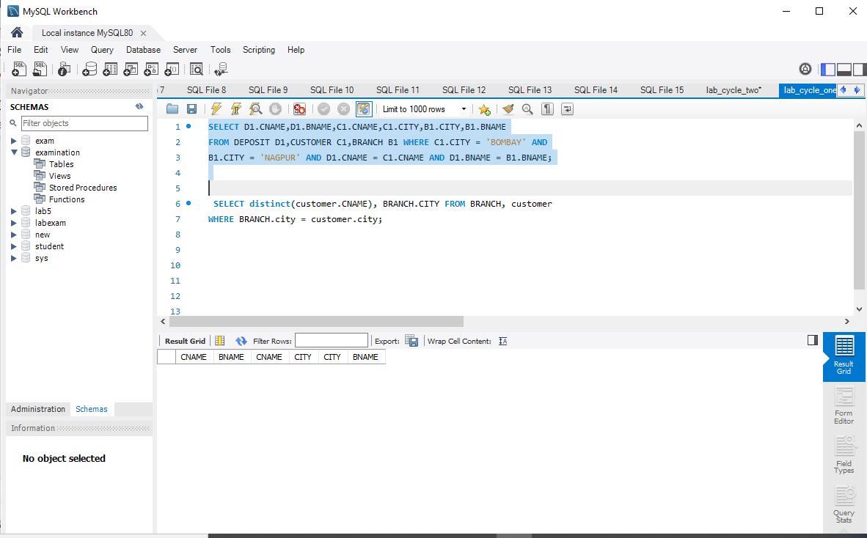

2.Give names of customers having the same living city as their branch city

SELECT distinct(customer.CNAME), BRANCH.CITY FROM BRANCH, customer

WHERE BRANCH.city = customer.city;

OUTPUT

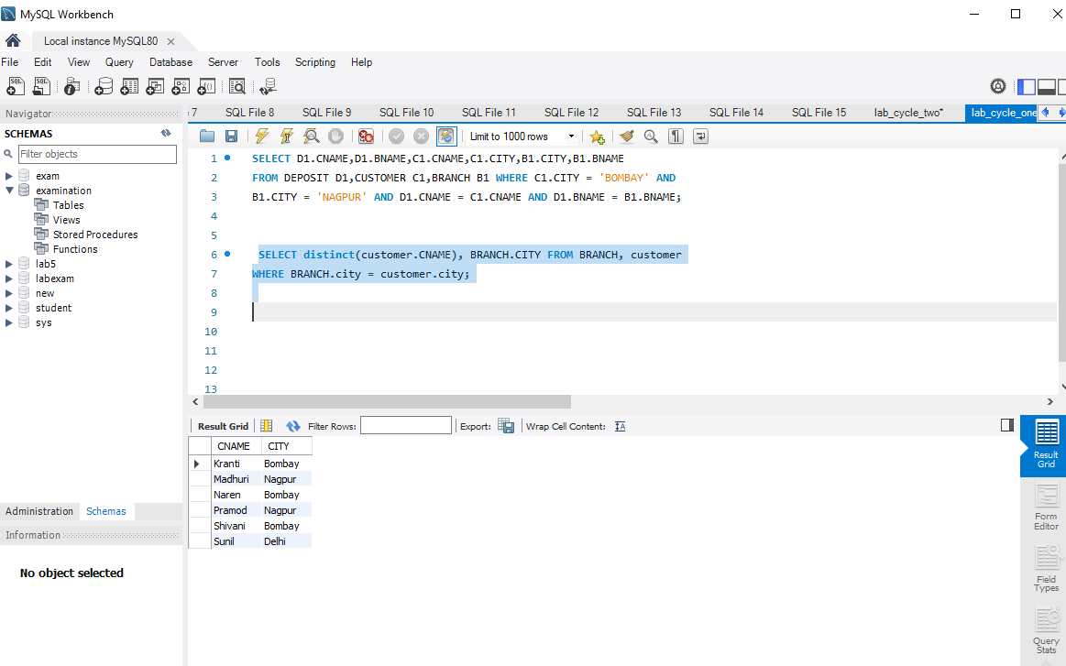

3.Give names of customers who are borrowers as well as depositors and having city

SELECT C1.CNAME FROM CUSTOMER C1,DEPOSIT D1,BORROW B1 WHERE

C1.CITY='NAGPUR' AND C1.CNAME=D1.CNAME AND D1.CNAME = B1.CNAME;

OUTPUT

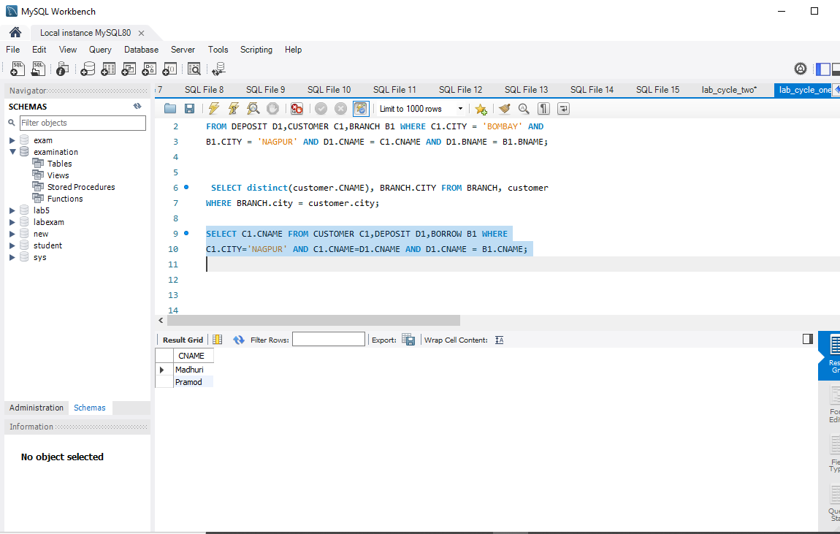

4.Give names of borrowers having deposit amount greater than 1000 and loan amount greater

than 2000.

SELECT BR1.CNAME, BR1.AMOUNT, D1.CNAME, D1.AMOUNT FROM

BORROW BR1,DEPOSIT D1 WHERE D1.CNAME = BR1.CNAME AND D1.AMOUNT >

1000 AND BR1.AMOUNT > 2000;

OUTPUT

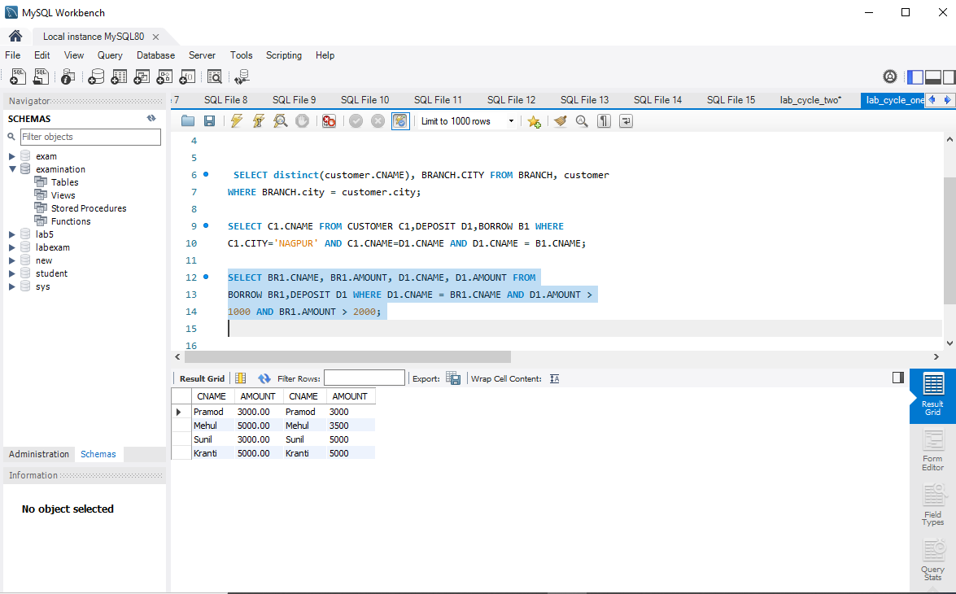

5.Give names of depositors having the same branch as the branch of Sunil

SELECT D1.CNAME FROM DEPOSIT D1 WHERE D1.BNAME IN (SELECT

D2.BNAME FROM DEPOSIT D2 WHERE D2.CNAME = 'SUNIL');

OUTPUT

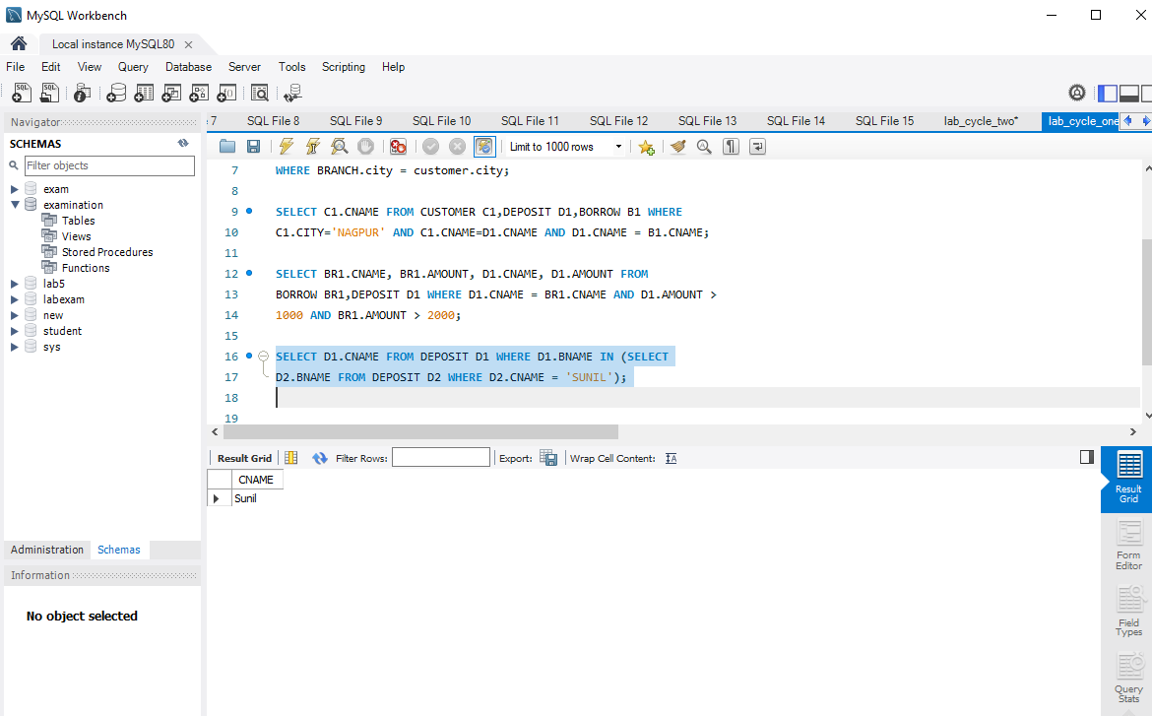

6.Give names of borrowers having loan amount greater than the loan amount of Pramod

SELECT BR1.CNAME,BR1.AMOUNT FROM BORROW BR1 WHERE

BR1.AMOUNT > ALL (SELECT BR2.AMOUNT FROM BORROW BR2 WHERE

BR2.CNAME = 'PRAMOD');

OUTPUT

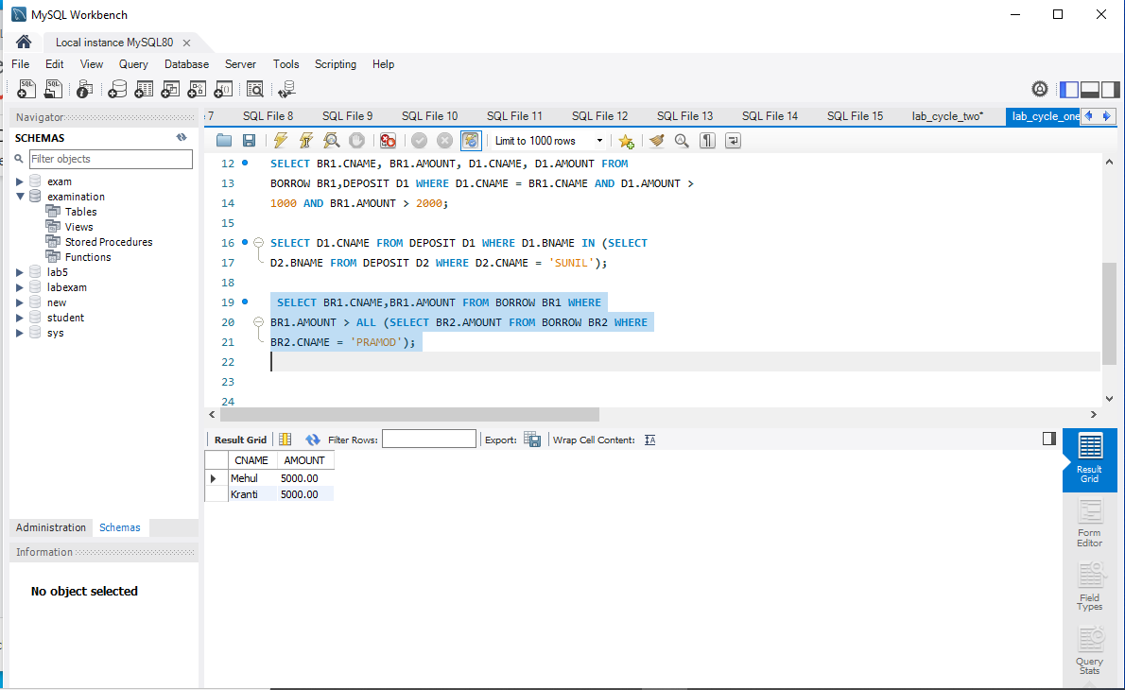

7.Give the name of the customer living in the city where branch of depositor Sunil is located.

SELECT C.CNAME FROM CUSTOMER C WHERE C.CITY IN (SELECT B.CITY

FROM BRANCH B WHERE B.BNAME IN (SELECT D.BNAME FROM DEPOSIT D

WHERE D.CNAME='SUNIL'));

OUTPUT

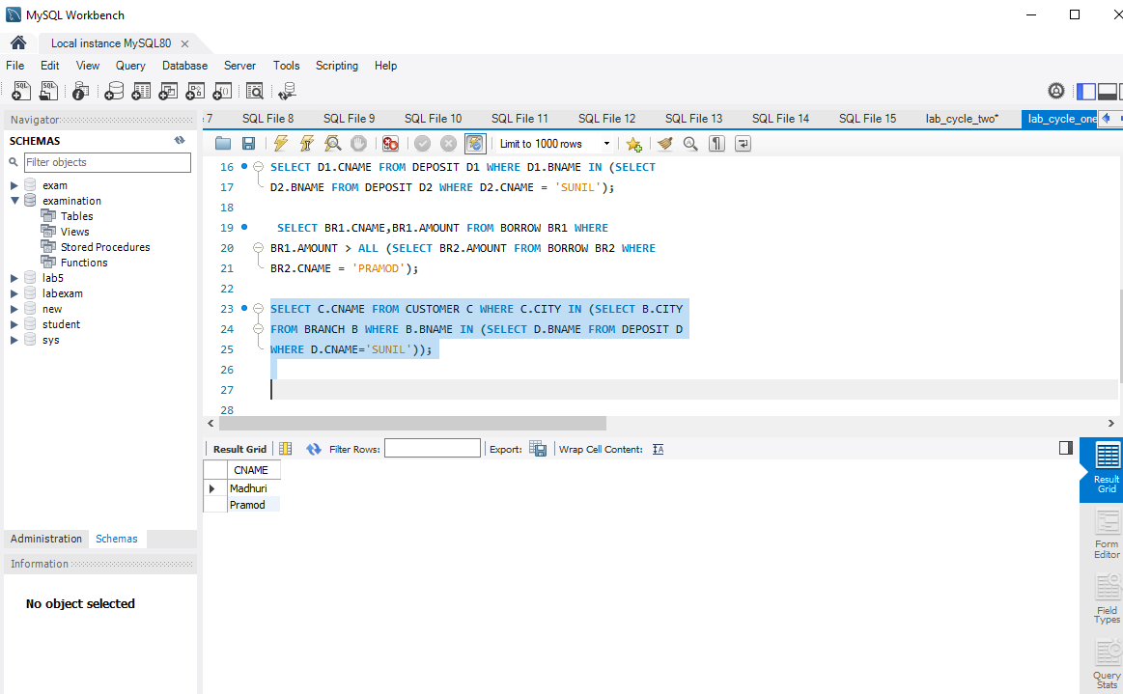

8.Give branch city and living city of Pramod

SELECT B1.CITY , C1.CITY FROM BRANCH B1,CUSTOMER C1, DEPOSIT D1

WHERE C1.CNAME = 'PRAMOD' AND C1.CNAME = D1.CNAME AND D1.BNAME =

B1.BNAME;

OUTPUT

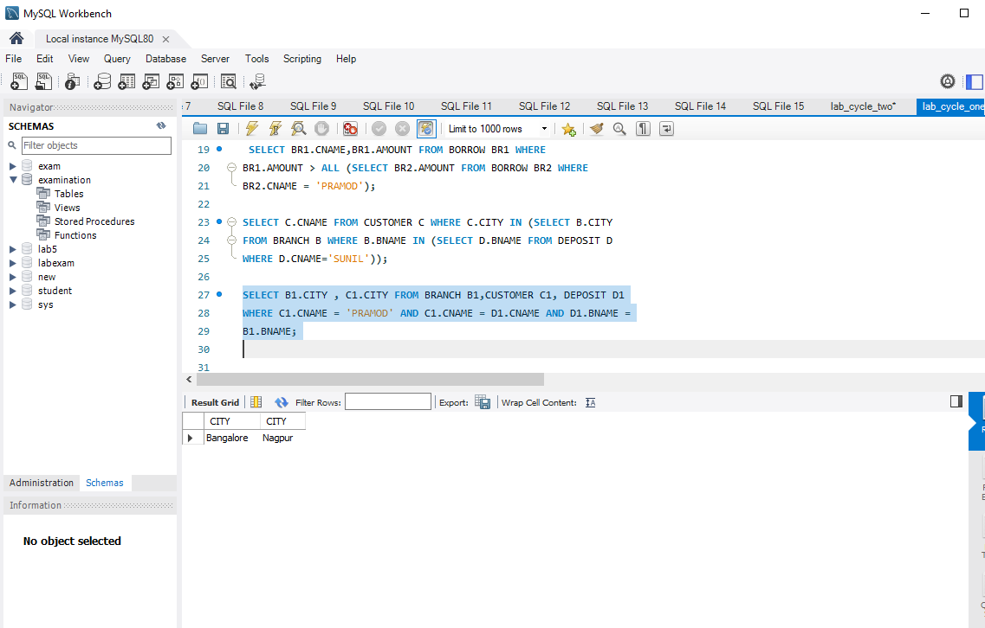

9.Give branch city of Sunil and branch city of Anil

SELECT B1.CITY FROM DEPOSIT D1, BRANCH B1 WHERE D1.BNAME =

B1.BNAME AND D1.CNAME IN ('SUNIL' ,'ANIL');

OUTPUT

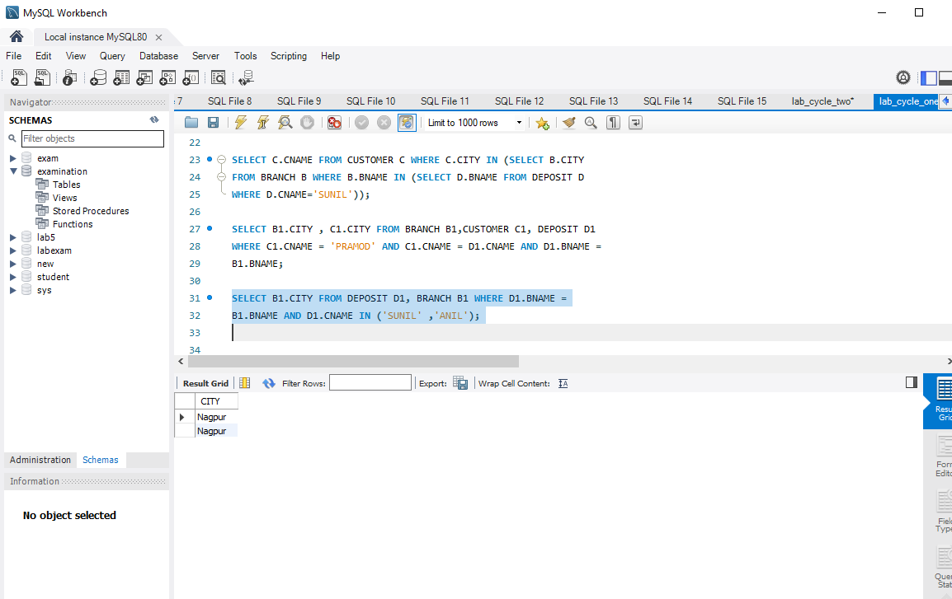

10.Give the living city of Anil and the living city of Sunil

SELECT C1.CNAME, C1.CITY FROM CUSTOMER C1 WHERE C1.CNAME =

'ANIL' OR C1.CNAME = 'SUNIL';

OUTPUT

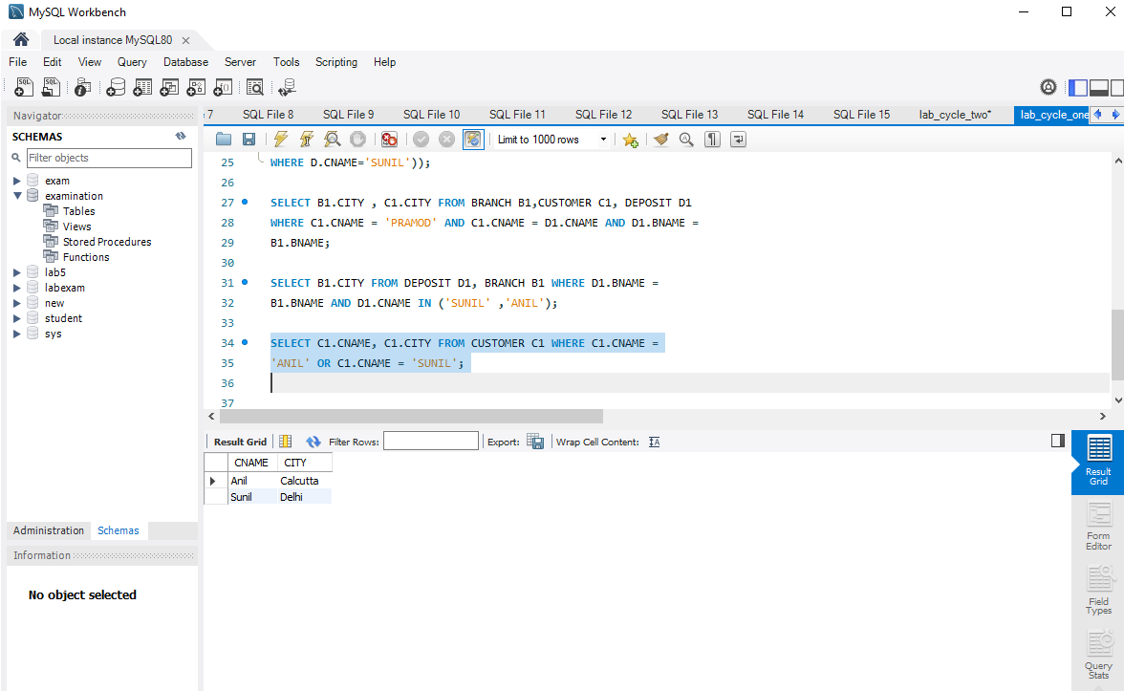

Experiment no:7

**AIM**

To familiarize with Group by and Having clause

Questions

1.List the branches having sum of deposit more than 5000.

SELECT D.BNAME FROM DEPOSIT D, BRANCH B WHERE

D.BNAME=B.BNAME AND B.CITY='BOMBAY' GROUP BY D.BNAME HAVING

SUM(D.AMOUNT)>5000;

OUTPUT

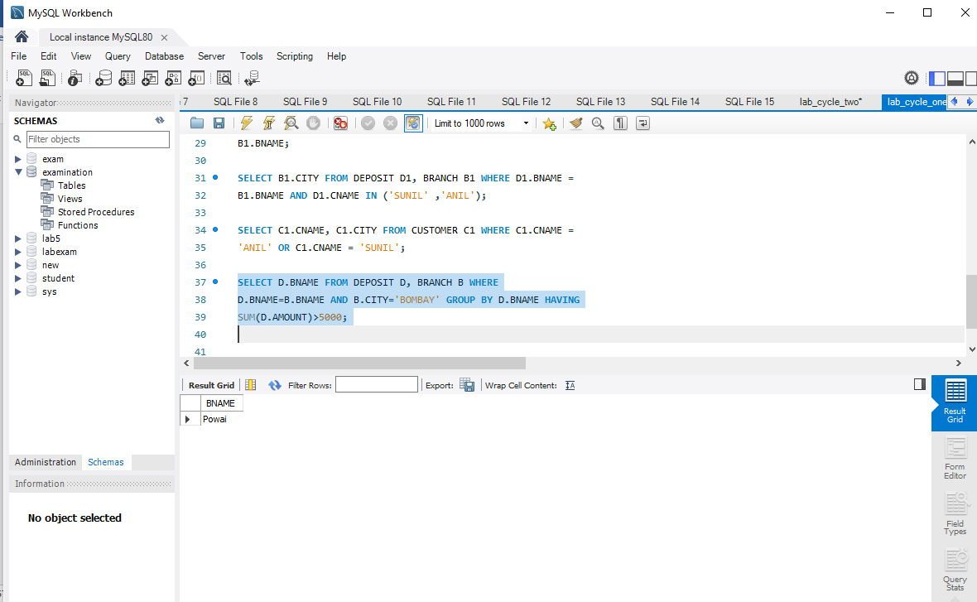

2.List the branches having sum of deposit more than 5000 and located in city BOMBAY

SELECT D.BNAME FROM DEPOSIT D, BRANCH B WHERE

D.BNAME=B.BNAME GROUP BY D.BNAME HAVING SUM(D.AMOUNT)>5000;

OUTPUT

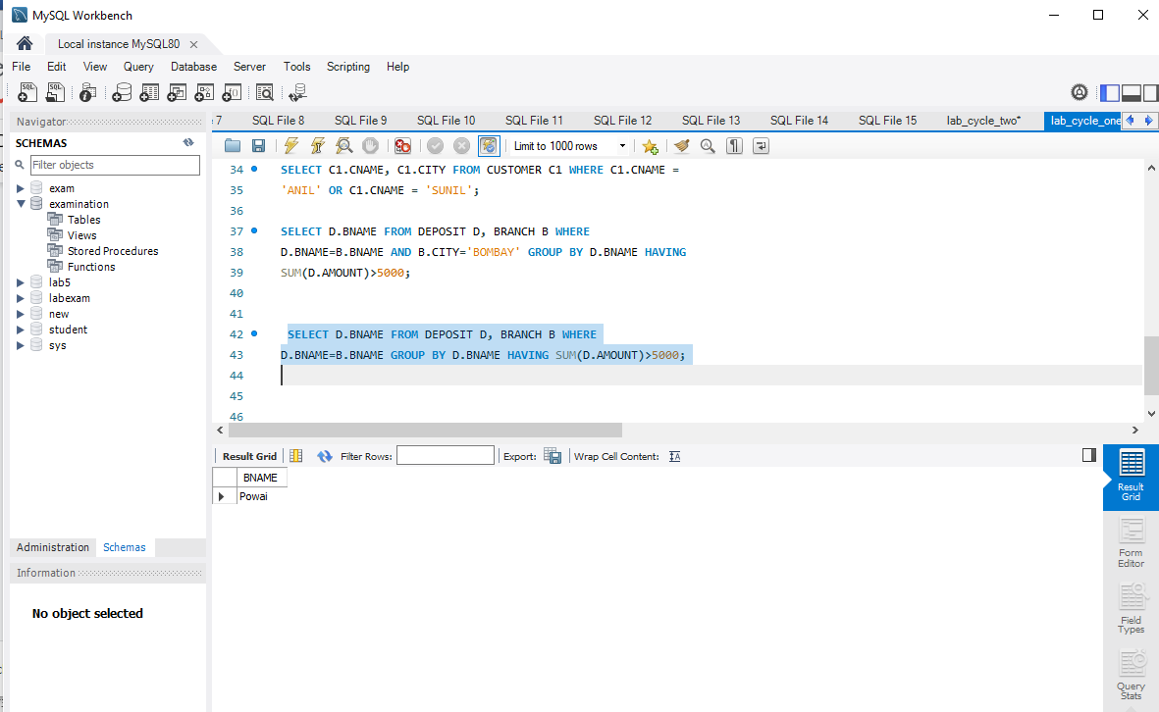

3.List the names of customers having deposited in the branches where the average deposit is

more than 5000.

select CNAME from deposit where AMOUNT=(select AVG(Amount) from DEPOSIT

GROUP BY BNAME having AVG(Amount)>5000);

OUTPUT

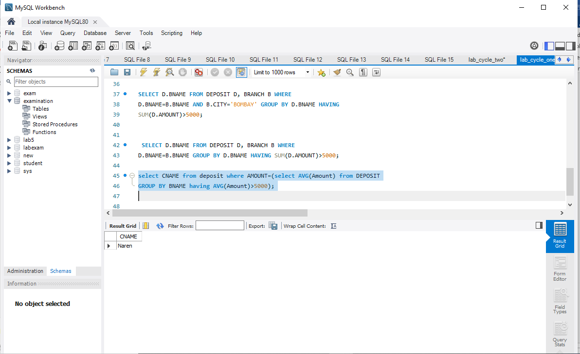

4.List the names of customers having maximum deposit

SELECT MAX(AMOUNT),CNAME FROM deposit;

OUTPUT

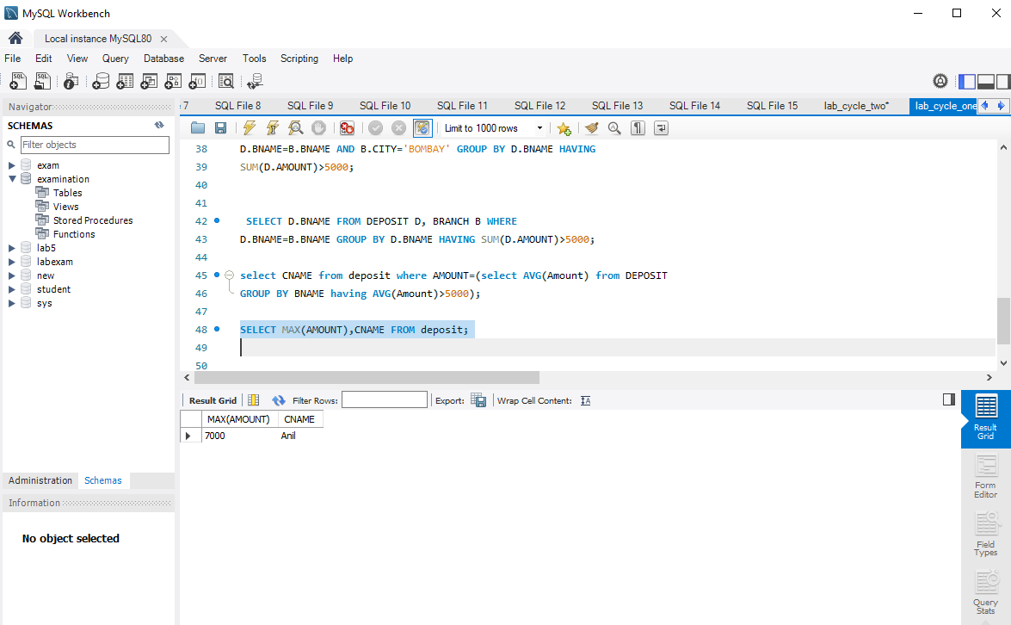

5.List the name of branch having highest number of depositors?

SELECT D1.BNAME FROM DEPOSIT D1 GROUP BY D1.BNAME HAVING

COUNT(D1.CNAME) >= ALL (SELECT COUNT(D2.CNAME) FROM DEPOSIT D2

GROUP BY D2.BNAME);

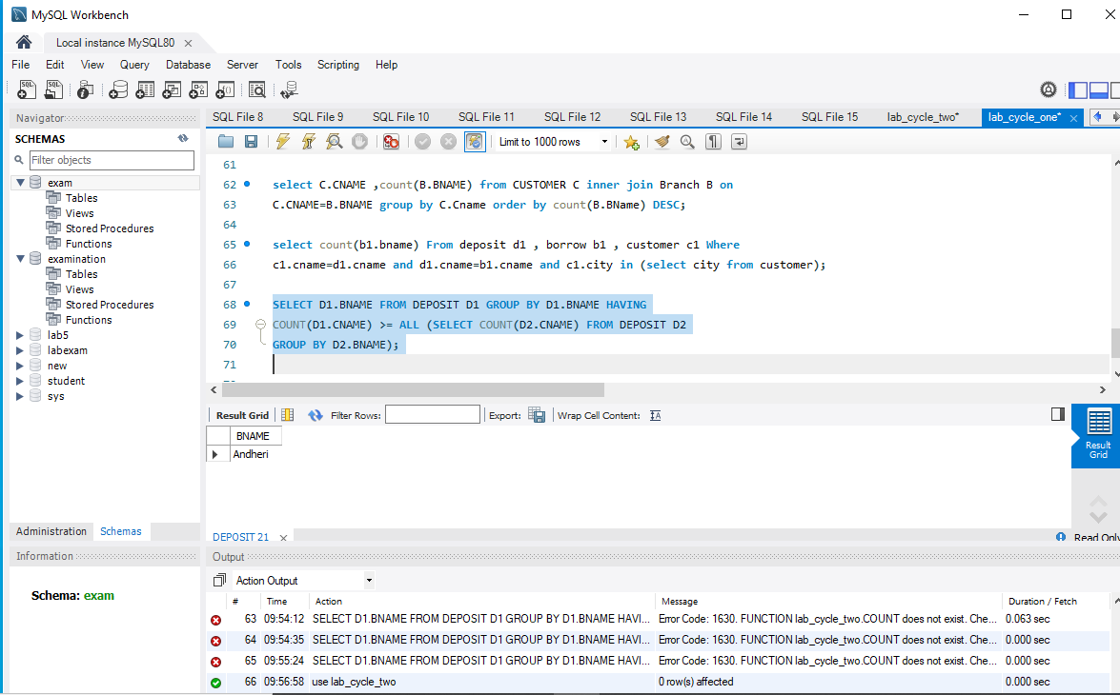

6.Count the number of depositors living in NAGPUR.

select count(deposit.cname)from deposit,CUSTOMER where

CUSTOMER.CITY='nagpur';

OUTPUT

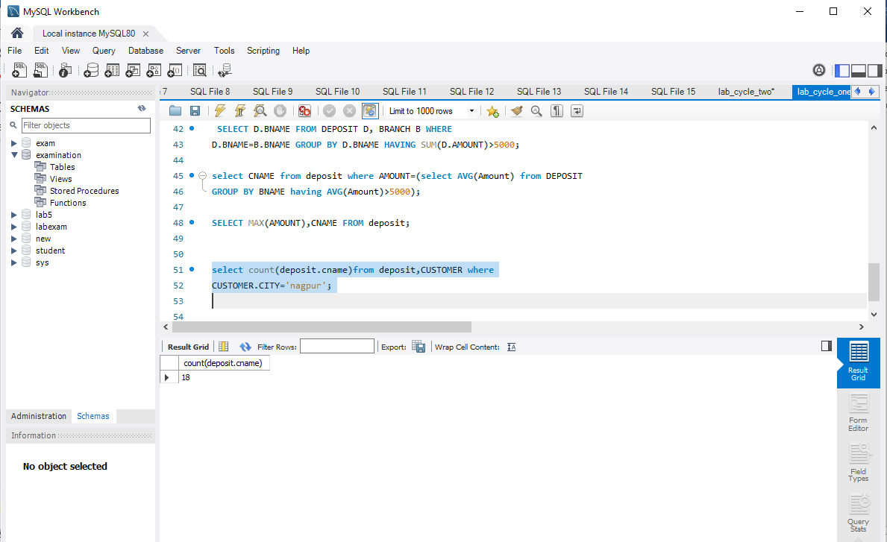

7.Give names of customers in VRCE branch having more deposite than any other customer in same branch

Select CNAME from deposit where BNAME='VRCE' and amount=(select

max(AMOUNT) from deposit where BNAME='VRCE');

OUTPUT

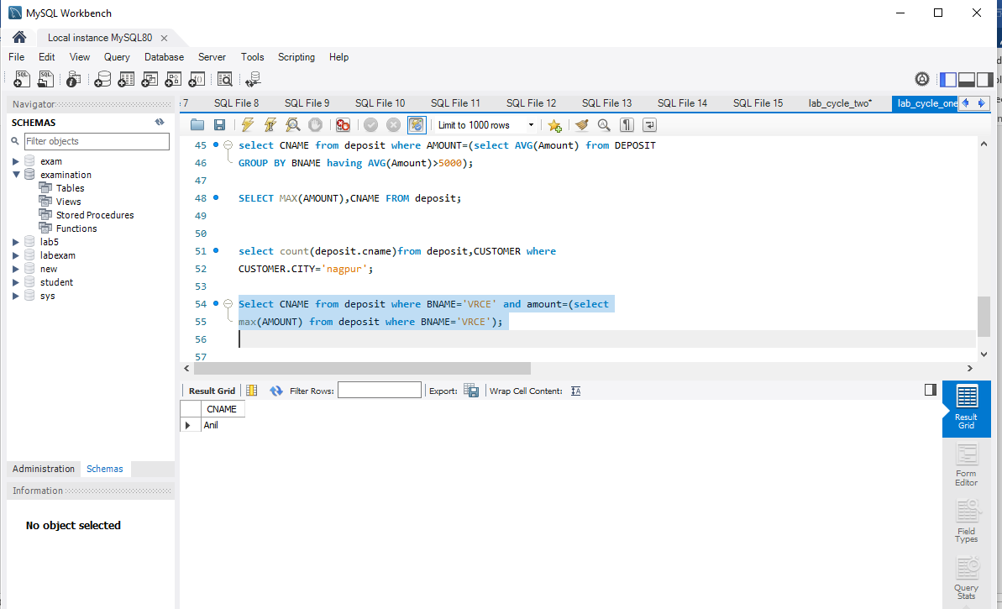

8.Give the names of branch where number of depositors is more than 5

SELECT BNAME from deposit GROUP BY BNAME HAVING

COUNT(BNAME)>5;

OUTPUT

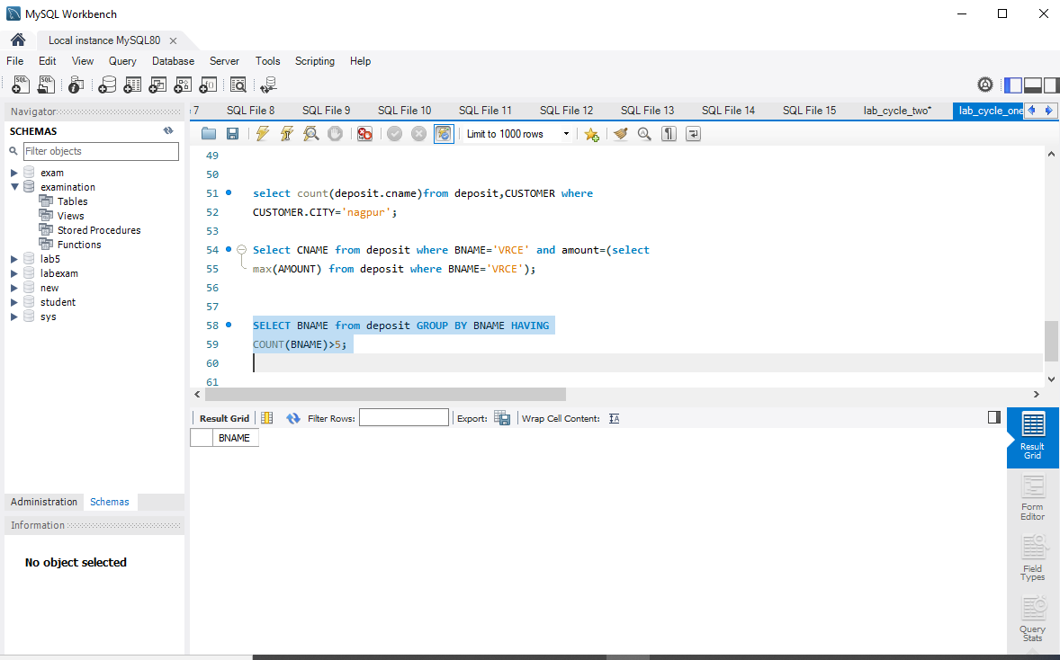

9.Give the names of cities in which the maximum number of branches are located

select C.CNAME ,count(B.BNAME) from CUSTOMER C inner join Branch B on

C.CNAME=B.BNAME group by C.Cname order by count(B.BName) DESC;

OUTPUT

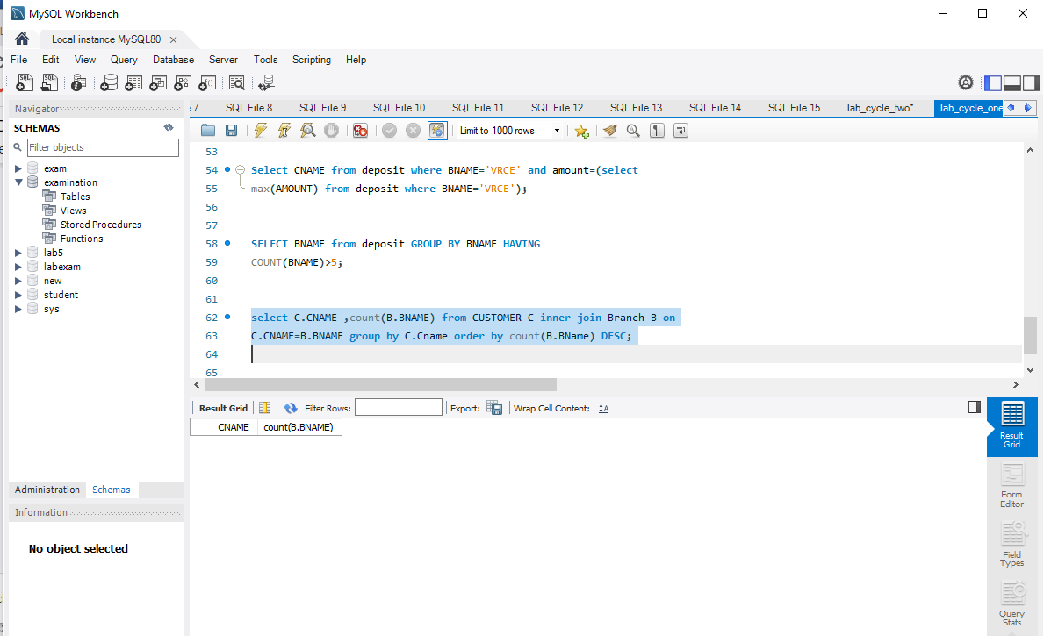

10.Count the number of customers living in the city where branch is located

select count(b1.bname) From deposit d1 , borrow b1 , customer c1 Where

c1.cname=d1.cname and d1.cname=b1.cname and c1.city in (select city from customer);

OUTPUT

